# **VEHICLE SERVICE ADMINISTRATION**

*A*

*Mini Project Report*

*Submitted in partial fulfilment of the*

*Requirements for the award of the Degree of*

**BACHELOR OF ENGINEERING**

IN

**INFORMATION TECHNOLOGY**

By

CHARAN SUTHARI – 1602-19-737-007

MD.IJAZ – 1602-19-737-022

THULLURU SANJAY SURYA – 1602-19-737-037



**Department of Information Technology**

**Vasavi College of Engineering (Autonomous)**

**(Affiliated to Osmania University)**

**Ibrahimbagh, Hyderabad-31**

**2020**

**Vasavi College of Engineering (Autonomous)**

**(Affiliated to Osmania University)**

**Hyderabad-500 031**

**Department of Information Technology**



**DECLARATION BY THE CANDIDATE**

We, CHARAN SUTHARI, MD IJAZ and SANJAY SURYA THULURU bearing hall ticket numbers, 1602-19-737-007,1602-19737-022 and 1602-19-737-037, hereby declare that the project report entitled “VEHICLE SERVICE ADMINISTRATION” is submitted in partial fulfilment of the requirement for the award of the degree of Bachelor of Engineering in Information Technology.

This is a record of bonafide work carried out by us and the results embodied in this project report have not been submitted to any other university or institute for the award of any other degree or diploma.

CHARAN SUTHARI

1602-19-737-007

MD.IJAZ

1602-19-737-022

THULLURU SANJAY SURYA

1602-19-737-037

(Faculty In-Charge) (Head.Dept IT)

**Acknowledgements**

The satisfaction that accompanies the successful completion of this project would not be in complete without the mention of the people who made it possible, without whose constant guidance and encouragement would have made efforts go in vain. We consider ourselves privileged to express gratitude and respect towards all those who guided us through the completion of this project.

We convey thanks to my project guide Mrs. LEELAVATHI PALLAVA of Information technology Department for providing encouragement, constant support and guidance which was of a great help to complete this project successfully.

Last but not the least, we wish to thank our parents for financing our studies in this privileged Vasavi College of Engineering as well as for constantly encouraging us to learn engineering. Their personal sacrifice in providing this opportunity to learn engineering is gratefully acknowledged.

**ABSRACT**

We know that when a vehicle is taken out for service, there would be lots of manual work to be done. Like, security notes the vehicle’s details manually or he puts a tag to it. But in this menu driven system, we make a group of reference codes which is given to the owner of the vehicle. The reference codes will not be allotted for other vehicles. And the customer’s phone number plays an important role. We can search the details of the customers by just entering his phone number. And there will be a lot of services in this project, suppose the customer chooses the car option ,we provide all the options that are required to service a car. Such as general service, Vehicle wash, etc. This system is well structured in such a way that we note the current details of the vehicle and compare it with normal condition of the vehicle. When he wants to ask the bill he needs to tell his mobile no. and reference code. In this way we are trying to explore it. Our main intention is to save and retrieve the data .

**INTRODUCTION**

“VEHICLE SERVICE ADMINISTRATION”, a c programmed application which enables the admin of the garage or service point to store and retrieve the details of the Owners of the Vehicle. Like we see that many service repair points do not store the data, and there will be many manual things to be done such as remembering the faces of the owner of the vehicle and their vehicle numbers. This type of thing leads to misconceptions and there will be a lot of confusions. To make this system in an upgraded version we made our project.

* **ADVANTAGES:**

The main advantage of this system is that everything in well stored in file format and also except mechanics, there is no manual work to be done. We are able to see what each computer is doing and limiting certain actions and preventing things such as viruses spreading, also the amount of data storage available to each.

* **ADMINISTRATIVE SECTION:**

Since this is just an administrative program, the user must not operate the system. Only admin has the opportunity to handle it. For example in a meeseva we see that only the employee of that particular sections accepts and retrieves the information. In the same way our project works.

The options we provide are……

1. Add Information of the Vehicle
2. View Information of the Vehicle
3. Search for the Vehicle
4. Edit information of the Vehicle
5. Delete the information of the vehicle
6. Exit

TECHNOLOGY

To implement any project successfully, there will be technological requirements which can either be software or hardware requirements.

1. Software requirements:

Since our project was supposed to be based on the C programming language, it is a bare necessity to have the knowledge and syntaxes of the language and a proper compiler and text editor to run and write the programs.

Compiler: Some of the many C compilers include:

1. Borland turbo C
2. Tiny C compiler
3. Portable C compiler
4. GCC compiler
5. Clang

Among the many available compilers, we have installed and used the GCC compiler to run/execute the code for “Image Steganography” that we have written.

Text editor:

To actually write and complete a code in any language, a text editor is important. Some of the famous text editors are:

1. Vim editor
2. Notepad
3. Notepad++

Although these are some famous ones, we have installed ad made use of a text editor called Sublime Text. Around 400 lines of the source code for “image steganography” implementation in C has been written there.

Hardware requirements:

1. **RAM –** 512 MB
2. **INPUT DEVICES –** Keyboard
3. **OUTPUT DEVICES –** Monitor Software

DESIGN:



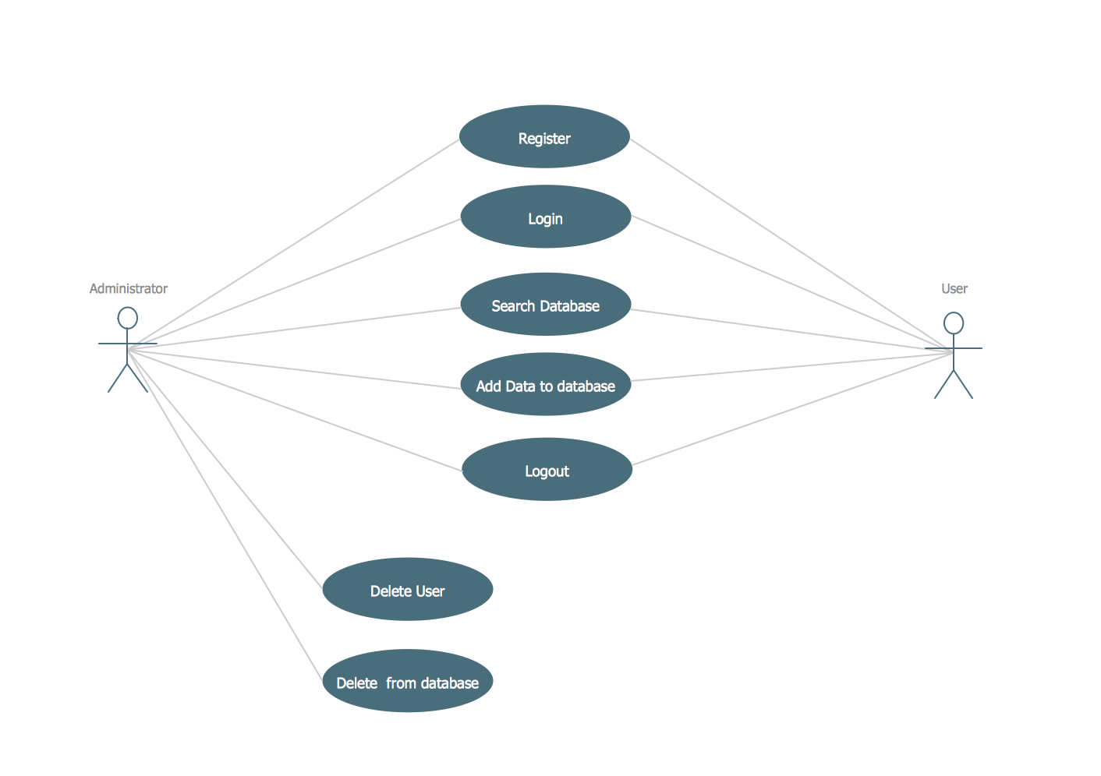

As we have mentioned that the only admin has the access to database and administrative works, user has the chance to see what admin is doing by connecting double monitors to single system.

IMPLEMENTATION:

This C Project creates a file & store information. We frequently use files for storing information which can be processed by our programs. In order to store information permanently and retrieve it we need to use files and this program demonstrate file creation and writing data in that.

* When a program is terminated, the entire data is lost. Storing in a file will preserve your data even if the program terminates.
* If you have to enter a large number of data, it will take a lot of time to enter them all.  
  However, if you have a file containing all the data, you can easily access the contents of the file using a few commands in C.
* You can easily move your data from one computer to another without any changes.
* In this project we also the implemented the concept of structures. It is just to make the user details more efficient and also to access them.
* Arrays allow to define type of variables that can hold several data items of the same kind. Similarly **structure** is another user defined data type available in C that allows to combine data items of different kinds.

In our program we used structure and its inbuilt functions to access input. And also we used strings which made us to input so many things such as Vehicle number, Owner name, etc . The inbuilt functions of strings made us to do the work so easy.

We have also implemented time.h library to generate random values for the purpose of coupon discount.

***Source Code:***

#include<stdio.h>

#include<string.h>

#include<stdlib.h>

#include <time.h>

struct ad //Defining Structure

{

char name[30];

char vehno[10];

char repair[30];

int refid,age, dd, mm, yyyy;

float tot;

char status[50];

char phone[30];

} x[100];

int n, i, j = 0, a = 0, sum = 0, g, flag, num;

void read ();

void write();

void add ();

void view ();

void search ();

void edit ();

void del ();

void show ();

void gen ();

void oil ();

void color ();

int main()

{

read ();

int c, i, q;

printf("*********************************************************************************************\n");

printf("\n");

printf ("******************************VEHICLE SERVICE ADMINISTRATION*******************************\n");

printf("\n");

printf("*********************************************************************************************\n");

int m, n;

//making out the pattern

while (c != 6)

{

printf("\t\t\t\t**Enter your choice**\n\n1. Add Information of the Vehicle\n\n\n\t\t\t2. View Information of the Vehicle\n\n\n3. Search of the Vehicle\n\n\n\t\t\t4. Edit Information of the Vehicle\n\n\n5. Delete Information of the Vehicle\n\n\n\t\t\t6. Exit\n\n\n\nOption=");

scanf ("%d", &c); //choice for option

if (c == 1) //add

{

add ();

}

else if (c == 2) //view

{

view ();

}

else if (c == 3) //search

{

search ();

}

else if (c == 4) //edit

{

edit ();

}

else if (c == 5) //delete

{

del ();

}

else if (c == 6)

{

write ();

return 0;

}

else

{

printf ("\n\nInvalid input , try again by using valid inputs");

}

printf ("\n\n");

}

}

void add()

{

int z;

printf ("\n");

printf ("Already data inputed on the database =%d\n\n", num); //how many inputs

printf ("Enter 1 to start....................\n");

scanf ("%d", &n);

while(1)

{

if(n!=1)

{

printf("Invalid input, enter 1 again...\n");

scanf("%d",&n);

}

else

{

break;

}

}

sum = n + num;

int wh1;

char g[30] = "General Service";

char o[30] = "Change in oil";

char c[30] = "Color Coating";

for (i = num, j = 0; i < sum; i++)

{

printf ("\n");

printf ("Enter Customer's Name: \n");

scanf ("%s", x[i].name);

printf ("\n");

printf ("\n");

printf ("Enter date of registering: \n");

scanf ("%d-%d-%d", &x[i].dd, &x[i].mm, &x[i].yyyy);

printf ("\n");

printf ("\n");

while(1)

{

if(x[i].dd>31||x[i].mm>12)

{

printf("Invalid Input, Please re enter date :\n");

scanf ("%d-%d-%d", &x[i].dd, &x[i].mm, &x[i].yyyy);

}

else

{

break;

}

}

printf ("Enter Vehicle number = \n");

scanf ("%s", x[i].vehno);

printf ("Enter the age = \n");

scanf ("%d", &x[i].age);

printf ("Enter Reference No. = \n");

scanf ("%d", &x[i].refid);

printf ("Enter phone number = \n");

scanf ("%s", x[i].phone);

while(1)

{

if(strlen(x[i].phone)>10||strlen(x[i].phone)<10)

{

printf("Invalid Input, Please re enter your phone number: \n");

scanf("%s", x[i].phone);

}

else

{

break;

}

}

printf ("What type of service you want to choose\n");

printf("1.General Service\n2.Change Oil\n3.Coating a new color to the vehicle\n");

scanf ("%d", &z);

if (z == 1)

{

strcpy (x[i].repair, g);

gen ();

}

else if (z == 2)

{

strcpy (x[i].repair, o);

oil ();

}

else if (z == 3)

{

strcpy (x[i].repair, c);

color ();

}

else

{

printf("Invalid Input, Please enter it again\n");

}

}

printf ("\n");

j++;

a++;

num++;

}

void view()

{

for (i = 0; i < num; i++)

{

printf ("\n");

printf ("Serial Number=%d\n", i);

printf ("Name = %s\n", x[i].name);

printf ("Vehicle Number =%s\n", x[i].vehno);

printf ("Reference no = %d\nAge=%d\n", x[i].refid, x[i].age);

printf ("Phone Number of Customer = %s\n", x[i].phone);

printf ("Total Payment= %f\n", x[i].tot);

printf ("Service = %s\n", x[i].repair);

printf("Status : ");

puts(x[i].status);

printf("Vehicle Details are viewed successfully\n");

printf ("\n\n");

}

}

void edit()

{

int q, p;

fflush (stdin);

printf ("What do you want to edit ?\n");

printf ("Enter your option\n");

printf ("1.Name\n2.Vehicle No.\n3.Age\n4.Reference id\n5.Phone no.\n6.Status\n");

printf ("Option=");

scanf ("%d", &q); //option

if (q < 7)

{

printf ("Enter the serial no of that Customer= (0 - %d)=", num - 1);

scanf ("%d", &p); //serial number

if (p < num)

{

if (q == 1)

{

fflush (stdin);

printf ("Enter the new name=");

scanf ("%s", x[p].name);

}

else if (q == 2)

{

fflush (stdin);

printf ("Enter the new Vehicle Number=");

scanf ("%s", x[p].vehno);

}

else if (q == 3)

{

fflush (stdin);

printf ("Enter the new Age=");

scanf ("%d", &x[p].age);

}

else if (q == 4)

{

fflush (stdin);

printf ("Enter the new Reference no=");

scanf ("%d", &x[p].refid);

}

else if (q == 5)

{

fflush (stdin);

printf ("Enter the new Phone no =");

scanf ("%s", x[p].phone);

}

else if (q == 6)

{

fflush (stdin);

printf ("Enter the new Status =");

scanf ("%s", x[p].status);

}

}

else

{

printf ("\n\nInvalid Serial \nTry Again !!\n\n");

}

}

printf("Vehicle Details are updated successfully\n");

}

void search ()

{

int s, h, f;

char u[100];

printf ("By what do you want to search ?\n");

printf("1.Serial no.\n2.Name\n3.Vehicle No.\n4.Reference ID.\n5.Phone no.\n\nOption = ");

scanf ("%d", &h);

if (h == 1)

{

printf ("Enter Serial number of the Customer=");

scanf ("%d", &s);

if (s < num)

{

printf ("\n");

printf ("Serial Number=%d\n", s);

printf ("Name = ");

puts (x[s].name);

printf ("Vehicle Number = ");

puts (x[s].vehno);

printf ("Reference no = %d\nAge = %d\n",x[s].refid, x[s].age);

printf ("Phone Number of Customer = %s\n", x[s].phone);

printf ("Money Paid= %f\n",x[s].tot);

printf("Service : ");

puts(x[s].repair);

printf("Status : ");

printf("\n");

puts(x[s].status);

printf("Vehicle Details are viewed successfully\n");

printf ("\n\n");

}

else

printf ("\n\nNot Found\n\n");

}

else if (h == 2) //problem is here.........

{

int f = 1;

fflush (stdin);

printf ("Enter your name=");

gets (u);

fflush (stdin);

for (g = 0; g < num; g++)

{

if (strcmp (u, x[g].name) == 0)

{

printf ("\n");

printf ("Serial Number=%d\n", g);

printf ("Name = ");

puts (x[g].name);

printf ("Vehicle No. = ");

puts (x[g].vehno);

printf ("Reference No. no = %d\nAge = %d\n",x[g].refid, x[g].age);

printf ("Phone Number of Customer = %s\n", x[g].phone);

printf ("Service= %s\n,Money Paid= %f\n", x[g].repair,x[g].tot);

printf("Status : ");

puts(x[g].status);

printf("Vehile Details are viewed successfully\n");

printf ("\n\n");

f = 0;

}

}

if (f == 1)

printf ("\nNot Found\n");

}

else if (h == 3)

{

int f = 1;

fflush (stdin);

printf ("Enter Vehicle Number = ");

gets (u);

fflush (stdin);

for (g = 0; g < num; g++)

{

if (strcmp (u, x[g].vehno) == 0)

{

printf ("\n");

printf ("Serial Number=%d\n", g);

printf ("Name = ");

puts (x[g].name);

printf ("Vehicle Number = ");

puts (x[g].vehno);

printf ("Reference no = %d\nAge = %d\n",x[g].refid, x[g].age);

printf ("Phone Number of Customer = %s\n", x[g].phone);

printf ("Service= %s\n,Money Paid= %f\n", x[g].repair,x[g].tot);

printf("Status : ");

puts(x[g].status);

printf("Vehicle Details are viewed successfully\n");

printf ("\n\n");

f = 0;

}

}

if (f == 1)

printf ("\nNot Found\n");

}

else if (h == 4)

{

int f = 1;

printf ("Enter Reference number = ");

scanf ("%d", &f);

for (g = 0; g < num; g++)

{

if (f == x[g].refid)

{

printf ("\n");

printf ("Serial Number=%d\n", g);

printf ("Name = ");

puts (x[g].name);

printf ("Vehicle Number = ");

puts (x[g].vehno);

printf ("Reference no = %d\nAge = %d\n",x[g].refid, x[g].age);

printf ("Service= %s\n,Money Paid= %f\n", x[g].repair,x[g].tot);

printf ("Phone Number of Customer = %s\n", x[g].phone);

printf("Status : ");

puts(x[g].status);

printf("Vehile Details are viewed successfully\n");

printf ("\n\n");

f = 0;

}

}

if (f == 1)

printf ("Not Found\n\n");

}

else if (h == 5)

{

int f = 1;

printf ("Enter Phone number = ");

gets(u);

for (g = 0; g < num; g++)

{

if (strcmp (u, x[g].phone) == 0)

{

printf ("\n");

printf ("Serial Number=%d\n", g);

printf ("Name = ");

puts (x[g].name);

printf ("Vehicle Number = ");

puts (x[g].vehno);

printf ("Reference no = %d\n\nAge = %d\n",x[g].refid, x[g].age);

printf ("Phone Number of Customer = %s\n", x[g].phone);

printf ("Service= %s\n,Money Paid= %f\n", x[g].repair, x[g].tot);

printf("Status : ");

puts(x[g].status);

printf("Vehicle Details are viewed successfully\n");

printf ("\n\n");

f = 0;

}

}

if (f == 1)

printf ("Not Found");

}

else

printf ("\n\nInvalid input\n\n");

}

void

del ()

{

int f, h;

printf ("Enter the serial number of the Customer that you want to delete=");

scanf ("%d", &f);

if (f < num)

{

printf ("What do you want ?\n");

printf

("1.Remove the whole record\n2.Remove Name\n3.Remove Vehicle Number\n4.Remove age\n5.Remove Reference Id\n6.Remove phone number\nOption = ");

scanf ("%d", &h);

if (h == 1)

{

while (f < num)

{

strcpy (x[f].name, x[f + 1].name);

strcpy (x[f].vehno, x[f + 1].vehno);

x[f].age = x[f + 1].age;

x[f].refid = x[f + 1].refid;

strcpy (x[f].phone, x[f + 1].phone);

f++;

}

num--;

}

else if (h == 2)

{

strcpy (x[f].name, "Cleared");

}

else if (h == 3)

{

strcpy (x[f].vehno, "Cleared");

}

else if (h == 4)

{

x[f].age = 0;

}

else if (h == 5)

{

x[f].refid = 0;

}

else if (h == 6)

{

strcpy (x[f].phone, "Cleared");

}

}

else

{

printf ("\n\nInvalid Serial number\n");

}

printf("Vehicle Details are deleted successfully\n");

}

void

read ()

{

FILE *fp = fopen ("details.txt", "r");

if (fp == NULL)

{

//create empty file, so that we can open it

//in the next execution of this program

fp = fopen ("details.txt", "w");

fclose (fp);

printf ("File does not exist, I JUST CREATED IT, exiting...\n\n\n");

}

num = fread (x, sizeof (struct ad), 100, fp);

fclose (fp);

}

void

write ()

{

FILE *fp = fopen ("details.txt", "w");

if (fp == NULL)

{

printf ("Error");

exit (1);

}

fwrite (x, sizeof (struct ad), num, fp);

fclose (fp);

}

void

gen ()

{

int br;

int j;

char pd[50] = "Paid";

char nd[50] = "Not Paid";

float brkk=50.0;

float washh=500.0;

float chainn=50;

float nob=0;

int coup_arr[5]={55452,55453,55454,55455,55456};

int c0,c2,c3,c4,c5,c6,c7,c8;

int coupg,coupg1,coupg2,coupg3,coupg4,coupg5,coupg6,coupg7;

printf ("General Service\n");

printf ("Did the mechanic check Brakes: \n1.Yes\n2.No\n");

scanf ("%d", &br);

if (br == 1)

{

printf ("The Mechanic has checked it -\n");

}

else if (br == 2)

{

printf ("The Mechanic has not checked it-\n");

}

printf ("Did the mechanic wash the vehicle: \n1.Yes\n2.No\n");

int vw;

scanf ("%d", &vw);

if (vw == 1)

{

printf ("Vehicle wash has been done\n");

}

else if (vw == 2)

{

printf ("Vehicle wash has not been done\n");

}

printf ("Did the mechanic check Chain System \n1.Yes\n2.No\n");

int cs;

scanf ("%d", &cs);

if (cs == 1)

{

printf ("Chain System has been checked\n");

}

else if (cs == 2)

{

printf ("Chain System hasn't been checked\n");

}

printf("Select among the following\n1.Brakes checked,Washing checked,Chain Checked\n2.Brakes checked,Washing Checked,Chain unchecked\n3.Brakes Checked,Washing unchecked,Chain unchecked\n4.Brakes unchecked,Washing unchecked,Chain Unchecked\n5.Brakes checked,Washing unchecked,Chain Checked\n6.Brakes unchecked,Washing checked,Chain checked\n7.Brakes unchecked,Washing checked,Chain unchecked\n8.Brakes unchecked,Washing unchecked,chain checked\n");

int chck;

scanf ("%d", &chck);

if (chck == 1)

{

printf ("The Total = %f/-\n",brkk+washh+chainn);

x[i].tot = brkk+washh+chainn;

printf("Does customer has coupon code?\n1.Yes\n2.No\n");

scanf("%d",&c0);

if(c0==1)

{

printf("Enter coupon code: \n");

scanf("%d",&coupg);

for(j=0;j<5;j++)

{

if(coup_arr[j]==coupg)

{

printf("You have succesfully claimed your discount of Rs.10\n");

x[i].tot = brkk+washh+chainn-10;

printf ("The Total = %f/-\n",x[i].tot);

break;

}

}

}

else if(c0 == 2)

{

printf("Since the customer does not have coupon code,\n");

printf ("The Total = %f/-\n",brkk+washh+chainn);

x[i].tot = brkk+washh+chainn;

}

}

else if (chck == 2)

{

printf ("The Total = %f/-\n",brkk+washh);

x[i].tot = brkk+washh;

printf("Does customer has coupon code?\n1.Yes\n2.No\n");

scanf("%d",&c2);

if(c2==1)

{

printf("Enter coupon code: \n");

scanf("%d",&coupg1);

for(j=0;j<5;j++)

{

if(coup_arr[j]==coupg1)

{

printf("You have succesfully claimed your discount of Rs.30\n");

break;

}

}

x[i].tot = brkk+washh-30;

printf ("The Total = %f/-\n",x[i].tot);

}

else if(c2==2)

{

printf("Since the customer does not have coupon code,\n");

printf ("The Total = %f/-\n",brkk+washh);

x[i].tot = brkk+washh;

}

}

else if (chck == 3)

{

printf ("The Total= %f/-\n",brkk);

x[i].tot = brkk;

printf("Does customer has coupon code?\n1.Yes\n2.No\n");

scanf("%d",&c3);

if(c3==1)

{

printf("Enter coupon code: \n");

scanf("%d",&coupg2);

for(j=0;j<5;j++)

{

if(coup_arr[j]==coupg2)

{

printf("You have succesfully claimed your discount of Rs.30\n");

x[i].tot = brkk-30;

printf ("The Total = %f/-\n",x[i].tot);

break;

}

}

}

else if(c3==2)

{

printf("Since the customer does not have coupon code,\n");

printf ("The Total = %f/-\n",brkk);

x[i].tot = brkk;

}

}

else if (chck == 4)

{

printf ("The Total = %f/=\n",nob);

x[i].tot = nob;

}

else if (chck == 5)

{

printf ("The total = %f/-\n",brkk+chainn);

x[i].tot = brkk+chainn;

printf("Does customer has coupon code?\n1.Yes\n2.No\n");

scanf("%d",&c5);

if(c5==1)

{

printf("Enter coupon code: \n");

scanf("%d",&coupg4);

for(j=0;j<5;j++)

{

if(coup_arr[j]==coupg4)

{

printf("You have succesfully claimed your discount of Rs.20\n");

x[i].tot = brkk+chainn-20;

printf ("The Total = %f/-\n",x[i].tot);

break;

}

}

}

else if(c5==2)

{

printf("Since the customer does not have coupon code,\n");

printf ("The Total = %f/-\n",brkk+chainn);

x[i].tot = brkk+chainn;

}

}

else if (chck == 6)

{

printf ("The Total = %f/-\n",washh+chainn);

x[i].tot = washh+chainn;

printf("Does customer has coupon code?\n1.Yes\n2.No\n");

scanf("%d",&c6);

if(c6==1)

{

printf("Enter coupon code: \n");

scanf("%d",&coupg5);

for(j=0;j<5;j++)

{

if(coup_arr[j]==coupg5)

{

printf("You have succesfully claimed your discount of Rs.20\n");

x[i].tot = washh+chainn-20;

printf ("The Total = %f/-\n",x[i].tot);

break;

}

}

}

else if(c6==2)

{

printf("Since the customer does not have coupon code,\n");

printf ("The Total = %f/-\n",washh+chainn);

x[i].tot = washh+chainn;

}

}

else if (chck == 7)

{

printf ("The Total = %f/-\n",washh);

x[i].tot = washh;

printf("Does customer has coupon code?\n1.Yes\n2.No\n");

scanf("%d",&c7);

if(c7==1)

{

printf("Enter coupon code: \n");

scanf("%d",&coupg6);

for(j=0;j<5;j++)

{

if(coup_arr[j]==coupg6)

{

printf("You have succesfully claimed your discount of Rs.20\n");

x[i].tot = washh-20;

printf ("The Total = %f/-\n",x[i].tot);

break;

}

}

}

else if(c7==2)

{

printf("Since the customer does not have coupon code,\n");

printf ("The Total = %f/-\n",washh);

x[i].tot = washh;

}

}

else if (chck == 8)

{

printf ("The Total = %f/-\n",chainn);

x[i].tot = chainn;

printf("Does customer has coupon code?\n1.Yes\n2.No\n");

scanf("%d",&c8);

if(c8==1)

{

printf("Enter coupon code: \n");

scanf("%d",&coupg7);

for(j=0;j<5;j++)

{

if(coup_arr[j]==coupg7)

{

printf("You have succesfully claimed your discount of Rs.20\n");

x[i].tot = washh-20;

printf ("The Total = %f/-\n",x[i].tot);

break;

}

}

}

else if(c8==2)

{

printf("Since the customer does not have coupon code,\n");

printf ("The Total = %f/-\n",chainn);

x[i].tot = chainn;

}

}

int pay;

printf (" Is payment process completed ?\n1.Yes\n2.No\n");

scanf ("%d", &pay);

if (pay == 1)

{

strcpy(x[i].status,pd);

}

else if (pay == 2)

{

strcpy(x[i].status,nd);

}

}

void

oil ()

{

int ol;

float egn=300.0;

float grl=150.0;

char pd1[30] = "Paid";

char nd1[30] = "Not Paid";

float nob1=0;

printf("Changing Oil\n");

printf("Did the mechanic add new Engine Oil\n1.Yes\n2.No\n");

scanf("%d",&ol);

if(ol==1)

{

printf("New Engine Oil has been added\n");

}

else if(ol==2)

{

printf("Engine oil has not been added\n");

}

int gr;

printf("Did mechanic add new gear oil\n1.Yes\n2.No\n");

scanf("%d",&gr);

if(gr==1)

{

printf("Gear oil has been added\n");

}

else if(gr==2)

{

printf("Gear oil has not been addded\n");

}

printf("Select among the follwing\n1.Engine Oil changed,Gear oil changed\n2.Engine Oil changed,Gear Oil not changed\n3.Engine Oil not changed,Gear Oil changed\n4.Engine Oil not changed,Gear oil not changed\n");

int chck1;

scanf("%d",&chck1);

if(chck1==1)

{

printf("The total = %f\n",egn+grl);

x[i].tot=egn+grl;

}

else if(chck1==2)

{

printf("The total = %f\n",egn);

x[i].tot=egn;

}

else if(chck1==3)

{

printf("The total = %f\n",grl);

x[i].tot=grl;

}

else if(chck1==4)

{

printf("The total = %f",nob1);

x[i].tot=nob1;

}

int pay1;

printf (" Is payment process completed ?\n1.Yes\n2.No\n");

scanf ("%d", &pay1);

if (pay1 == 1)

{

strcpy (x[i].status,pd1);

}

else if (pay1 == 2)

{

strcpy (x[i].status,nd1);

}

}

void

color ()

{

int cl;

char pd2[30] = "Paid";

char nd2[30] = "Not Paid";

printf("Colour Coating\n");

printf("Is Colour coating done?\n1.Yes\n2.No");

scanf("%d",&cl);

if(cl==1)

{

printf("Color Coating is completed\n");

}

else if(cl==2)

{

printf("Color Coating is not completed\n");

}

printf("Select among the follwing\n1.Color coating done\n2.Color coating not done\n");

float clr=1500.0;

int chck2;

float nob2=0.0;

scanf("%d",&chck2);

if(chck2==1)

{

printf("The total=%f\n",clr);

x[i].tot=clr;

}

else if(chck2==2)

{

printf("The total=%f\n",nob2);

x[i].tot=nob2;

}

int pay2;

printf("Is Payment Process done?\n1.Yes\n2.No\n");

scanf("%d",&pay2);

if(pay2==1)

{

strcpy (x[i].status,pd2);

printf("Congratulations,you have successfully won a coupon\nyou can avail it only if you opt for general service.\n");

int lower = 55452, upper = 55456;

srand(time(0));

printf("The coupon code is : \n");

int numcoup = (rand() % (upper - lower + 1)) + lower;

printf("%d ", numcoup);

}

else if(pay2==2)

{

strcpy (x[i].status,nd2);

}

}

TESTING:

To compile and execute the above source code for “**Vehicle Service Administration**”, the following are the commands:

Compilation: gcc prog.c -o prog



As we can see that no errors are found, we can run the program now.

Command to run the program :

prog.exe



The output we get is,

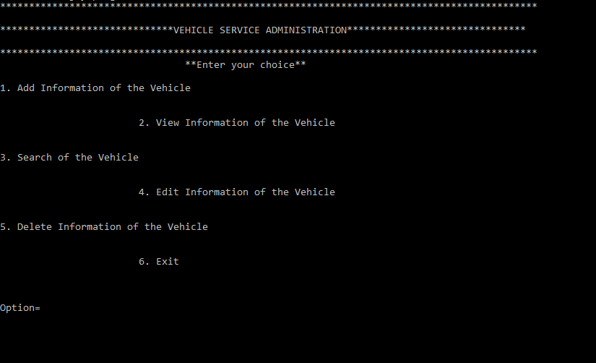

If we select option 1, we can add the details of the vehicle,

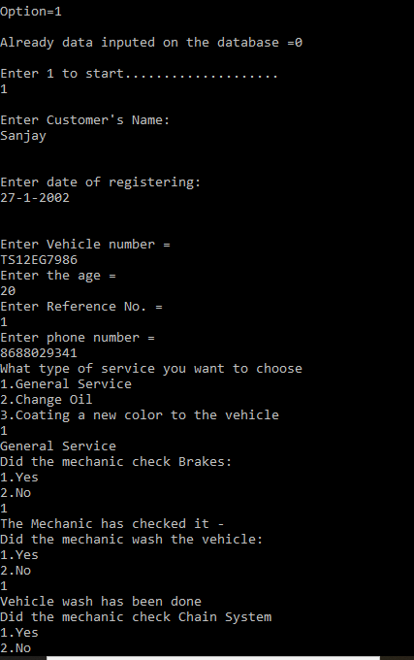

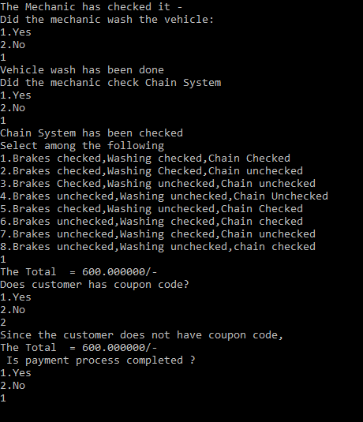

Let us view the information by selecting option 2

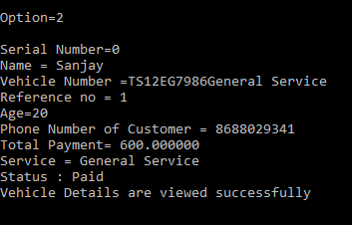

Let us use search function

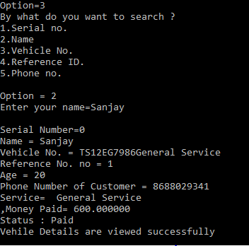

Let us use edit function

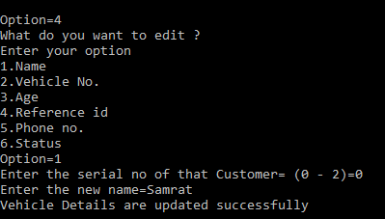

At last let us use delete function

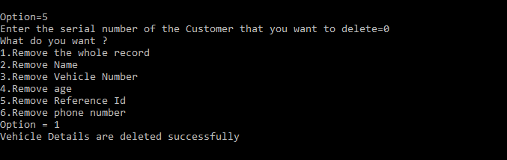

Coupon Code Application:

Suppose the customer has opted for vehicle wash, he will be getting coupon which can be used to get the discount in general service.

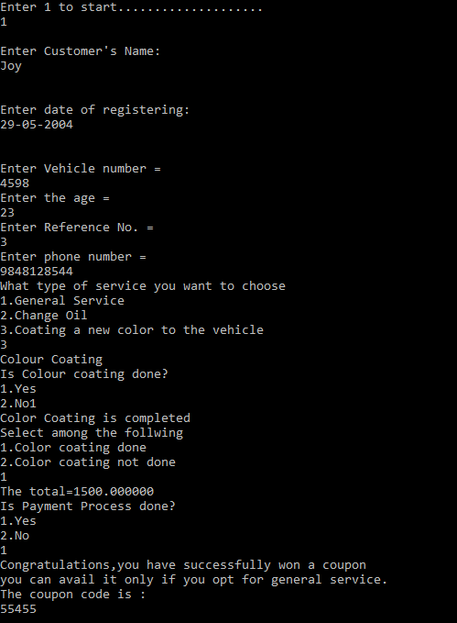

Now Let us apply it

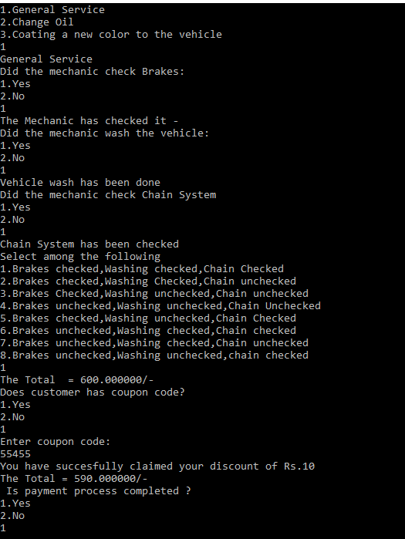

As we can see that there is a decrease in the cost from 600 to 590. The thing is that the code can be used by anyone and there is no validity for it. It is not the rule that only that particular customer must use the code, the code can be used by his mutual also.

Hence these are our test cases.

File storage:



**What is the additional knowledge gained as a result of implementing this mini project apart from the syllabus covered in the course programming for problem solving?**

Apart from c language we learnt much more uses of files structures and many algorithms in the data structures, etc .Not only this we have learnt may different concepts of structures to the files and many other different concepts.

We also explored time.h library for the function like srand(), to generate random values from an array.

DISCUSSION AND FUTURE WORK:

I think that our project will make the garage system into a high level way. Our future work includes incorporating more concepts such as Data Structures in our Learning and Quiz modules. Also, we would like to include a feature which allow the User to send requests to the Admin for any changes they require. Other than this, we are deliberating on increasing the authority of the Admin by shifting some features from read-only to editable access as well. This project can be further improved by converting it into a Web Application using Python and the Django Framework or a Mobile Application using Flutter or React Native.

GITHUB LINKS:

<https://github.com/sanjaydevlop/Mini-Project>

<https://github.com/charancodes>

REFERENCES:

<https://stackoverflow.com/>

<https://www.geeksforgeeks.org/>